Seth Ricks

ECEN380-01

Lab #2 MATLAB / Simulink & Signals

2/15/2026

Table of Contents

Abstract 3

Part A Procedure 4

Part B Procedure 5

Part C Procedure 14

Conclusion 30

# Abstract

Include a brief abstract detailing what has been done for the lab

List of useful/interesting things learned & Abstract

# Part A Procedure

include the completion certificate in your lab report.



Part B Procedure 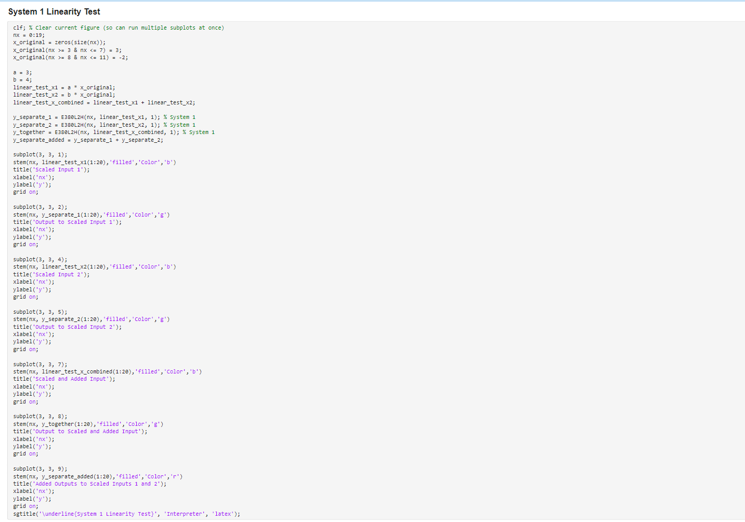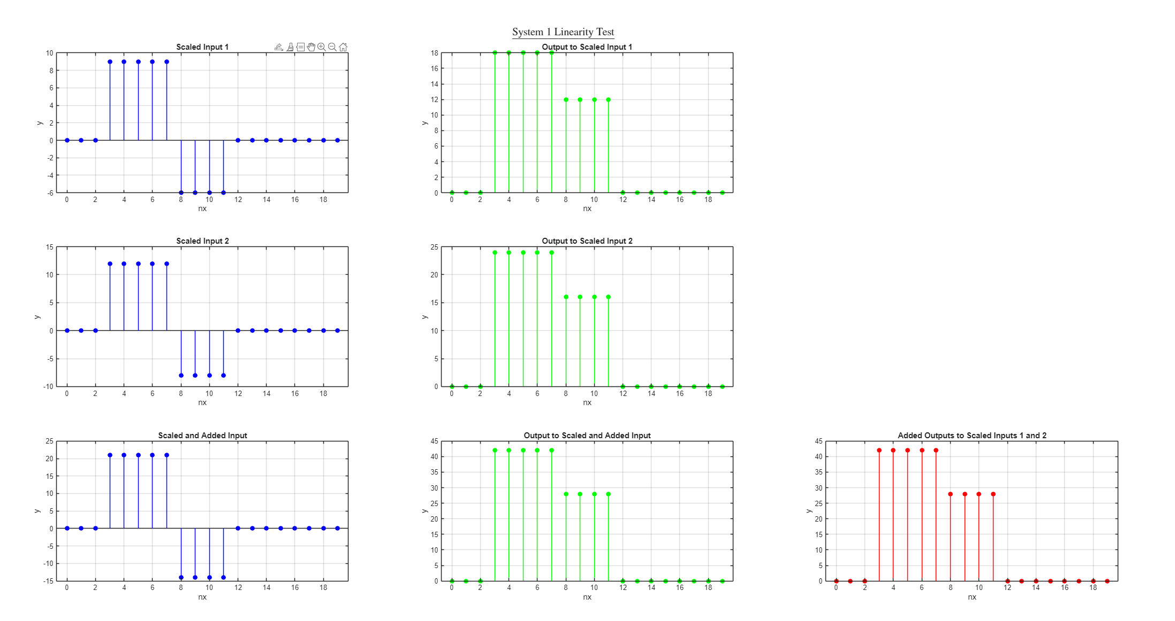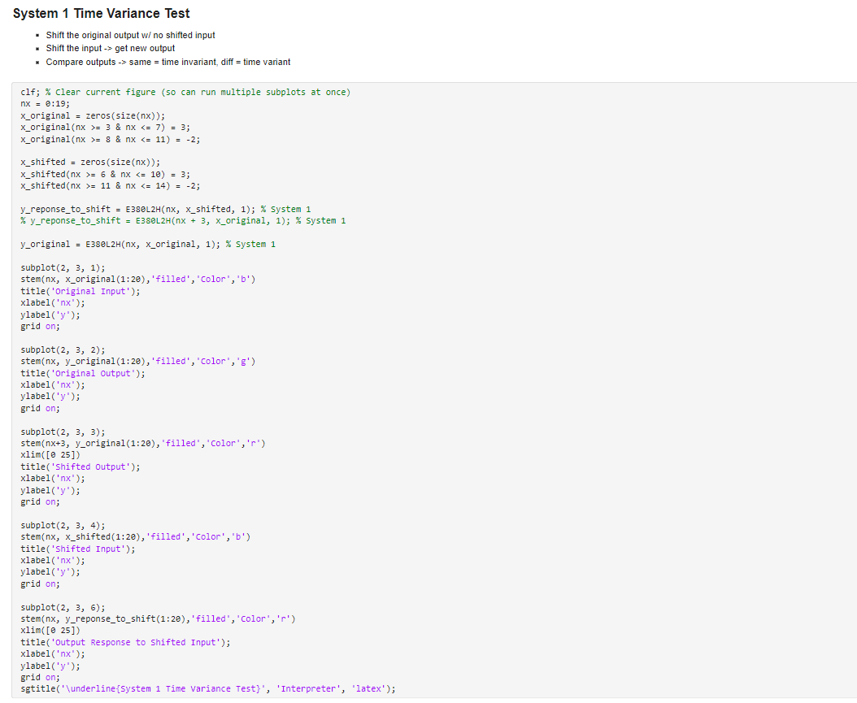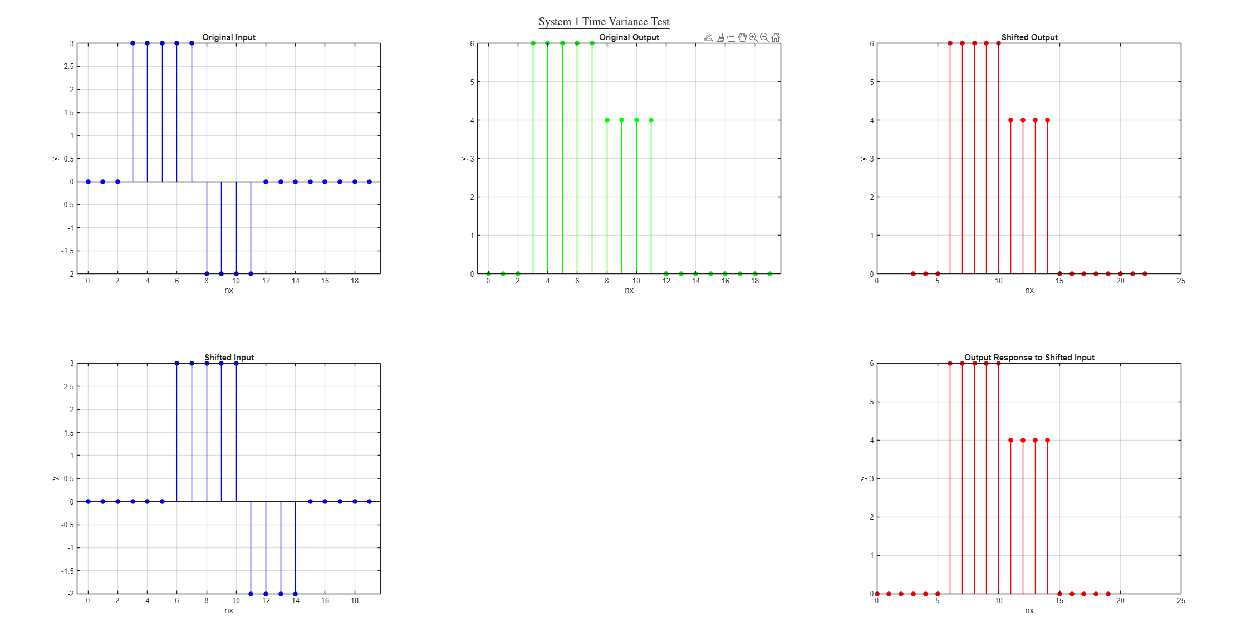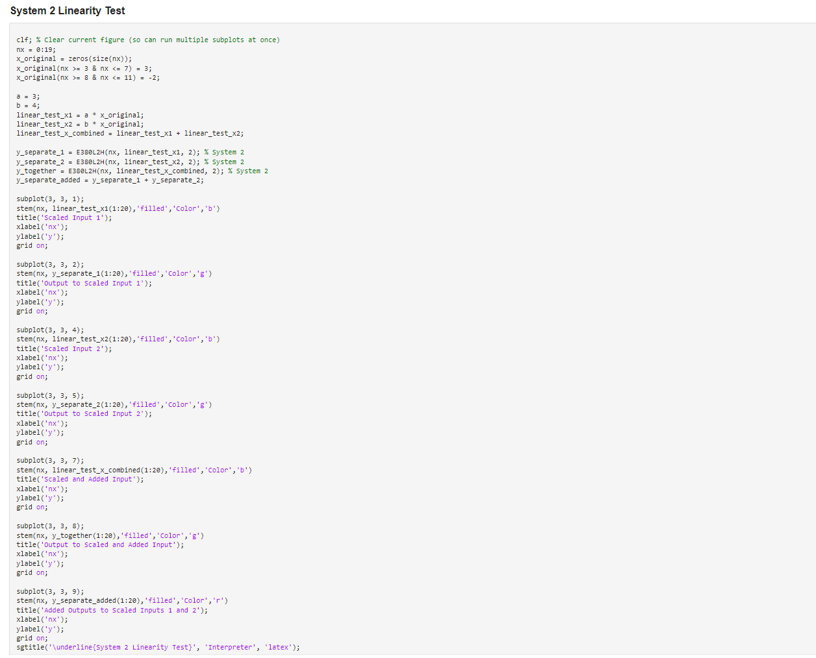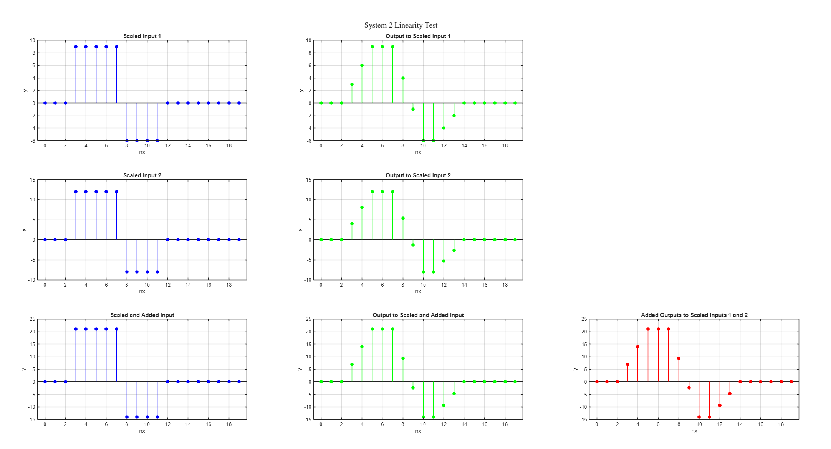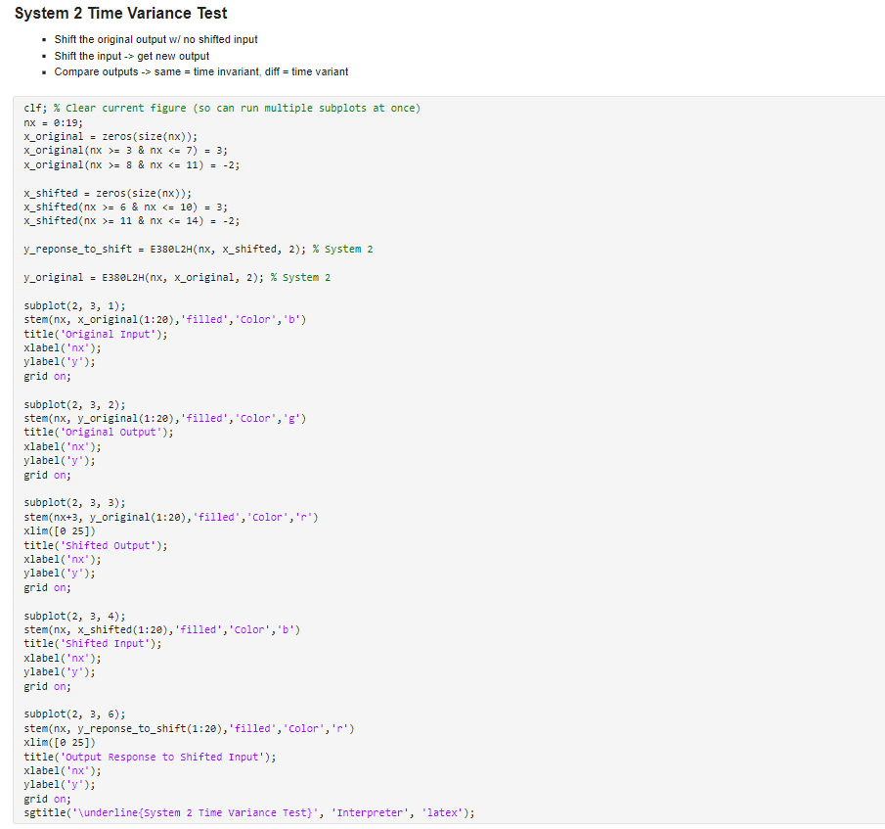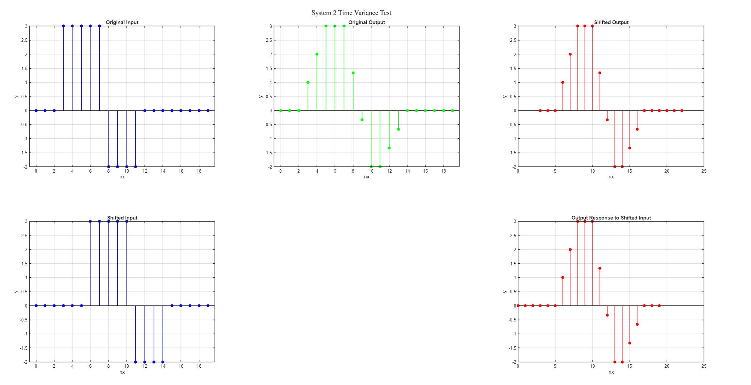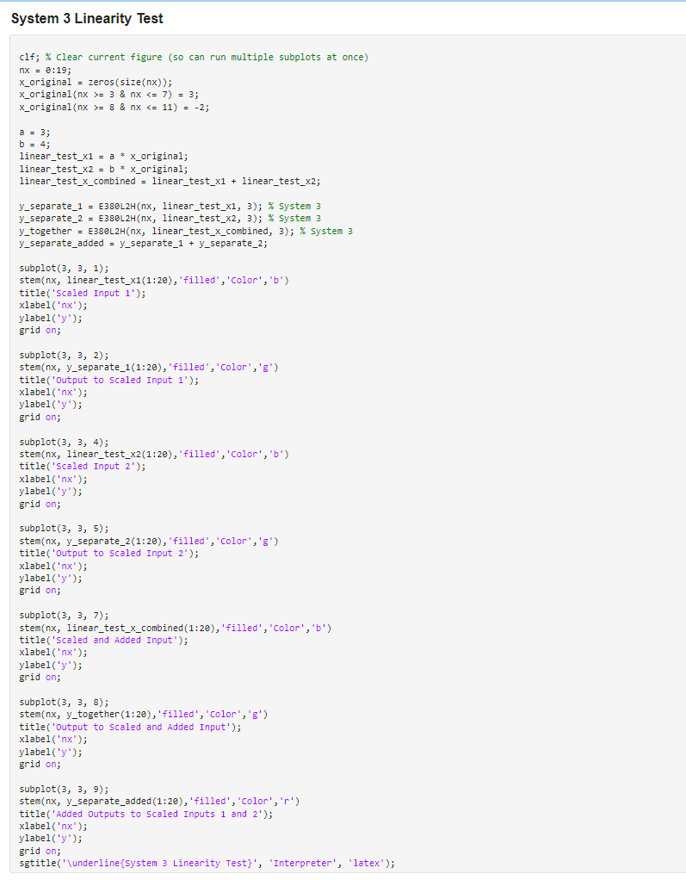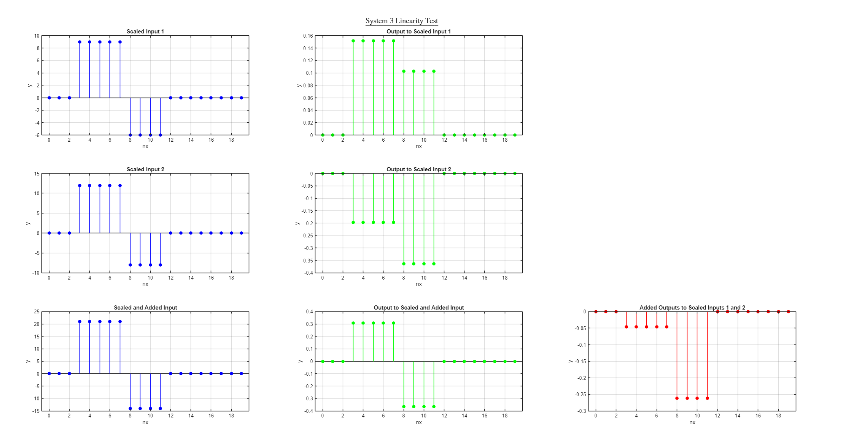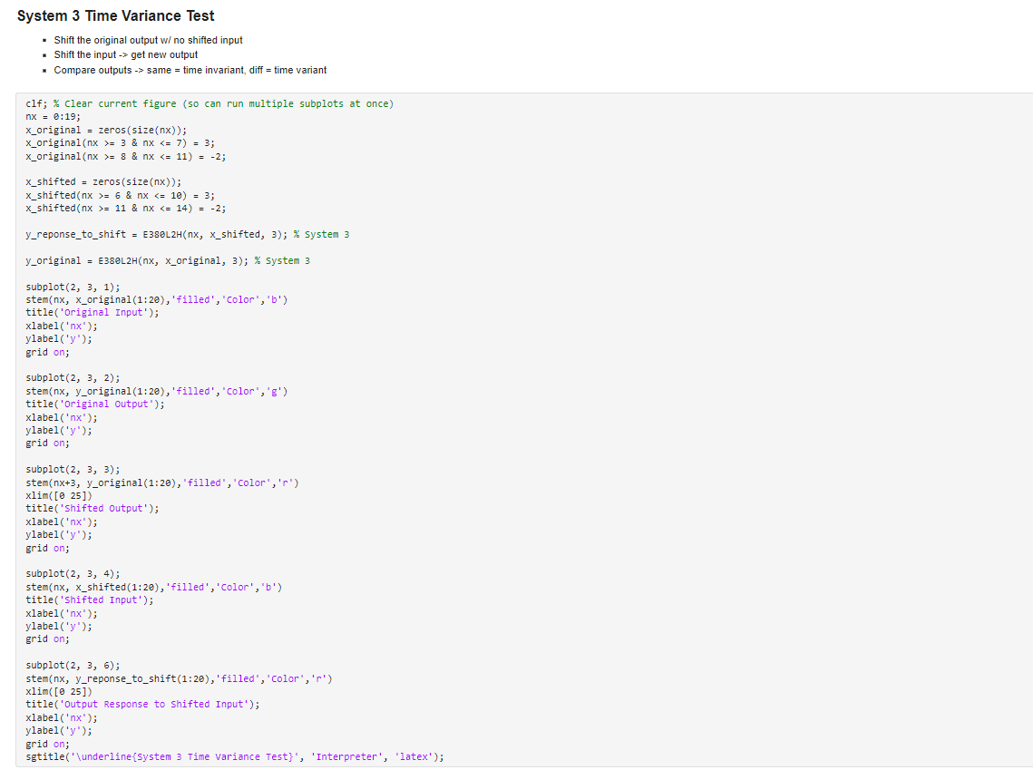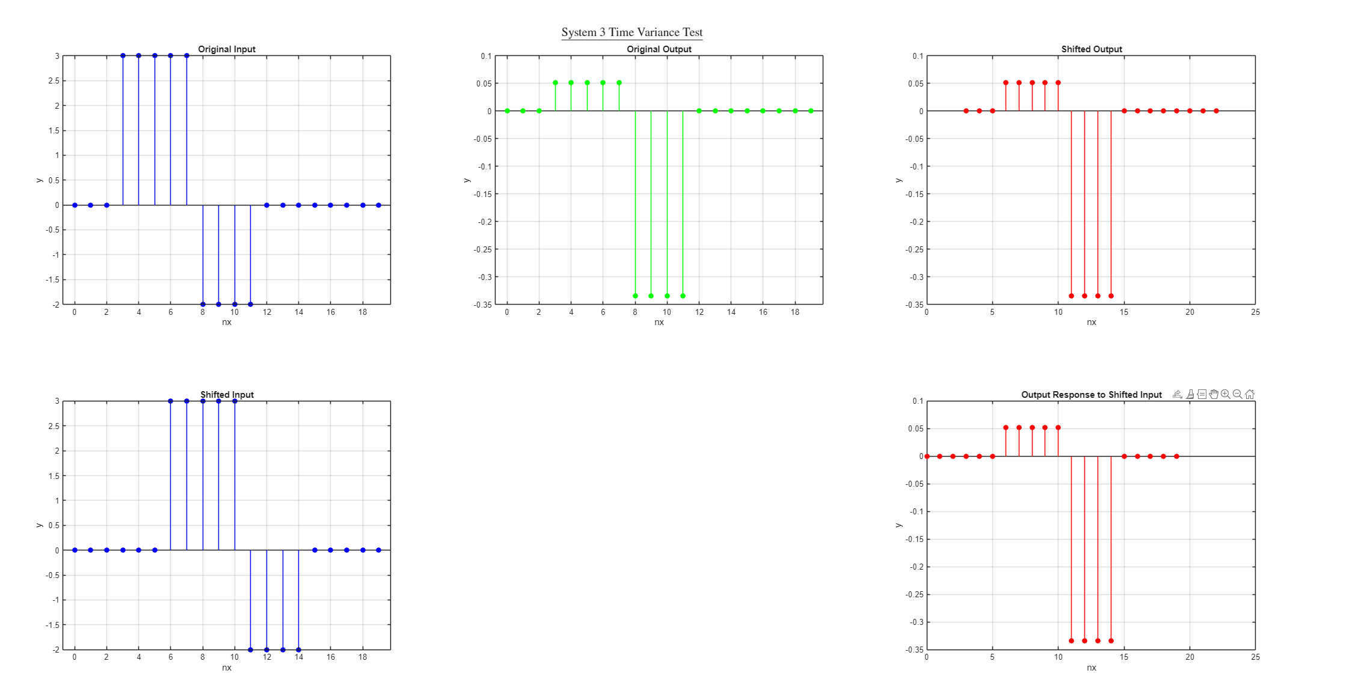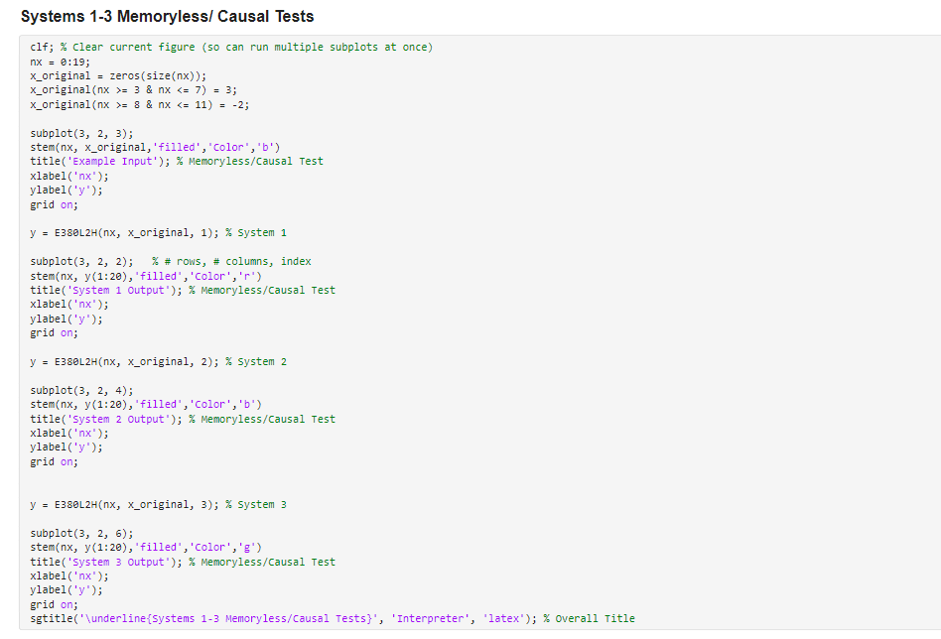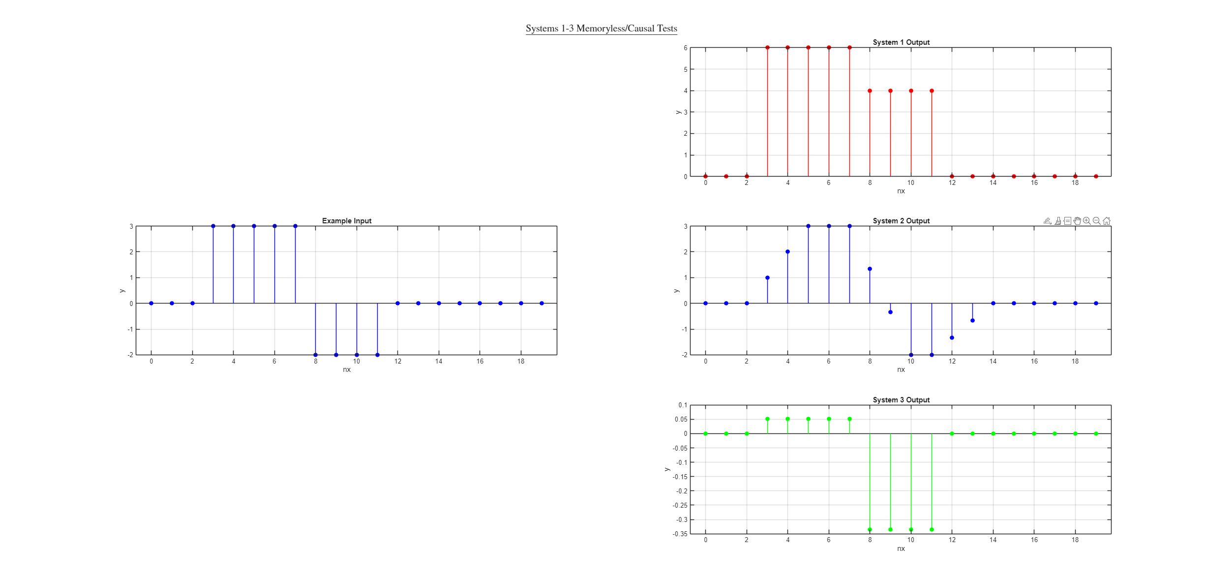

# Part C Procedure

9. Can you still measure the correct period at each frequency in Simulink? How or why not?

10. Try to explain why the 1002Hz signal looks the way it does in Simulink.

11. Could we recover the original waveform at each frequency? How or why not?

Show your work done for the procedure/practice section

Provide a brief explanation of the Simulink blocks used for the lab

Describe the things you learned or found interesting/useful

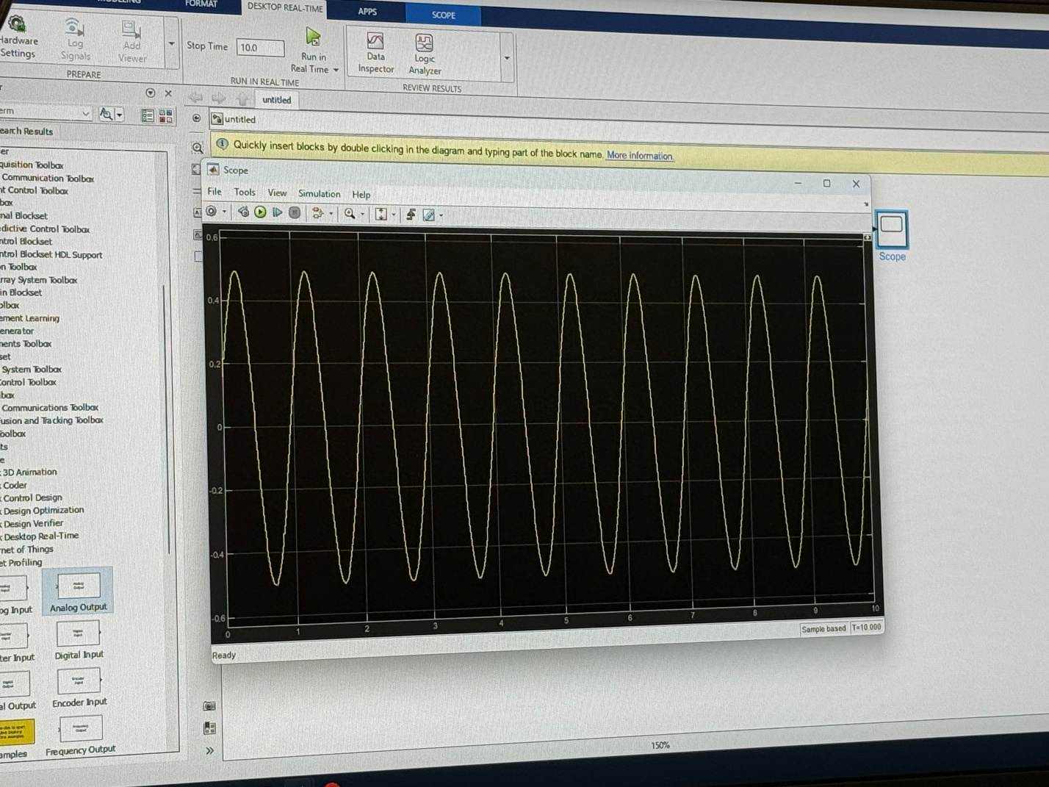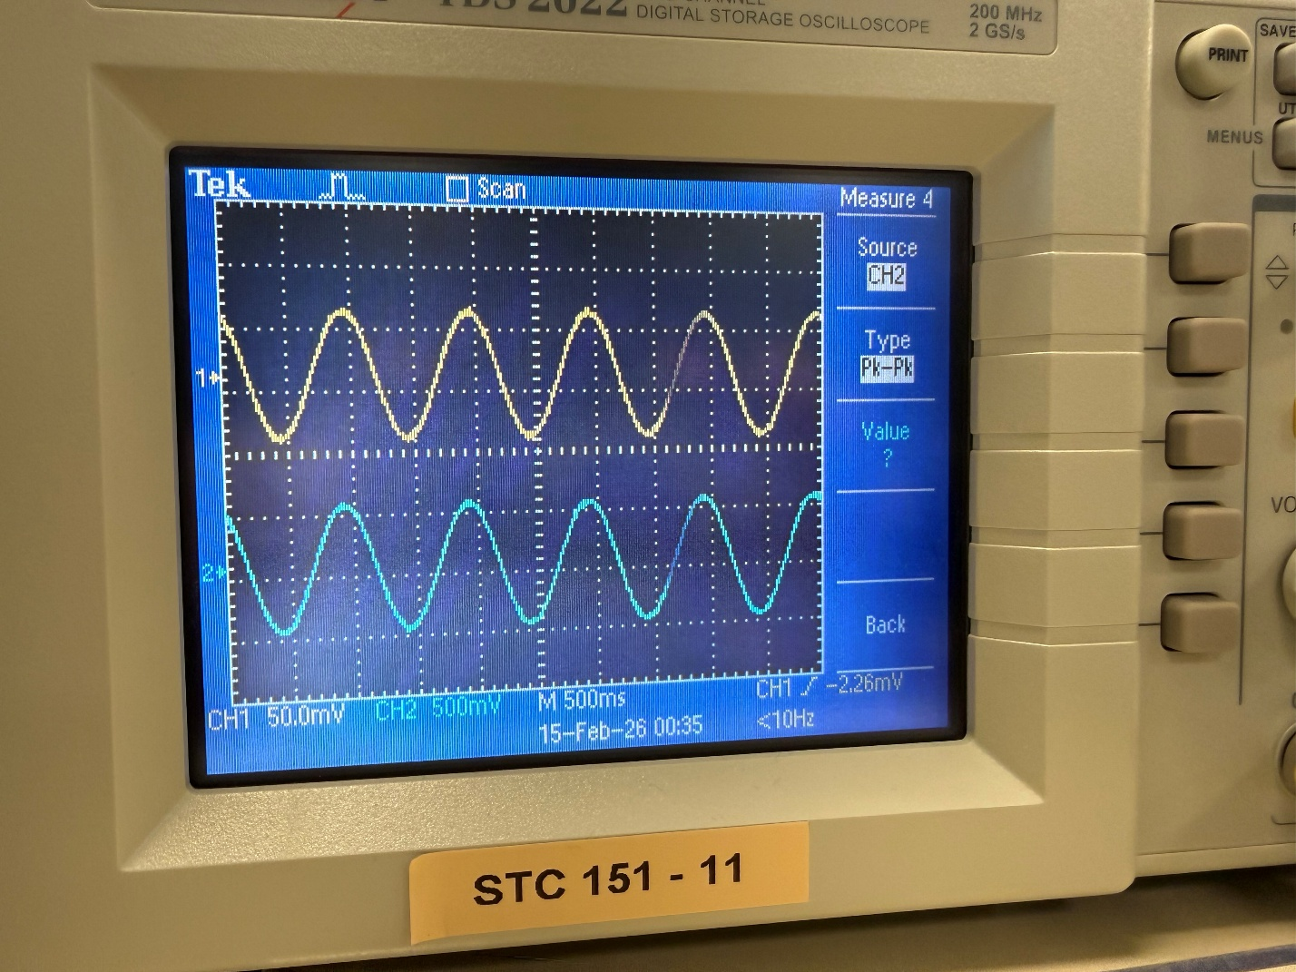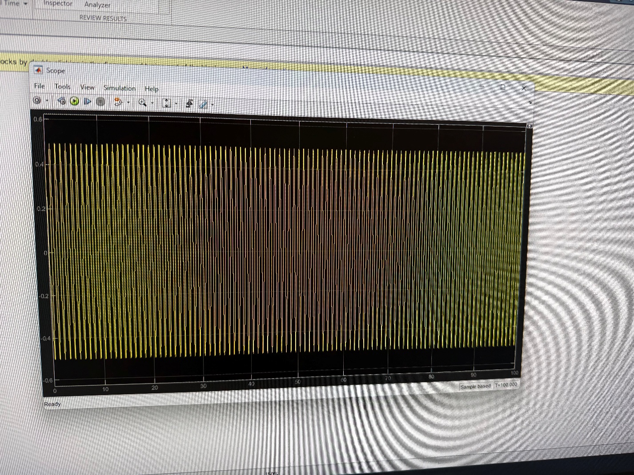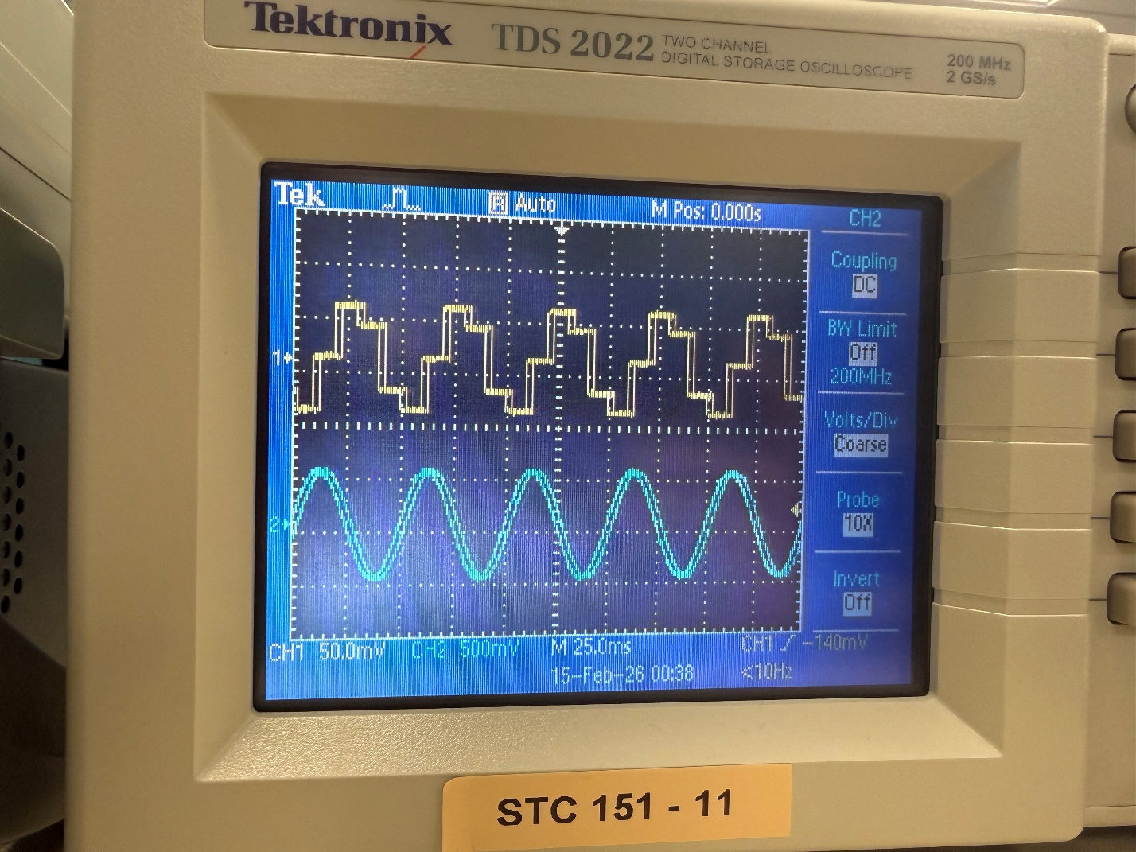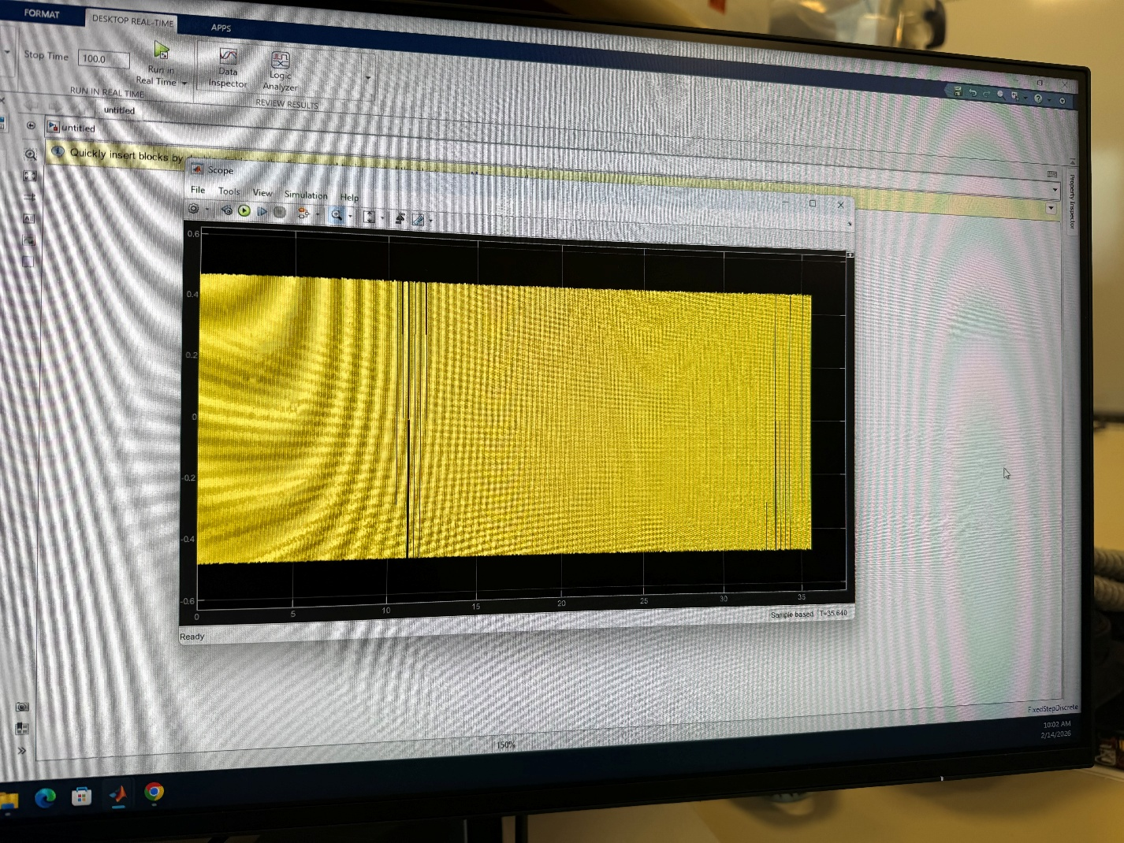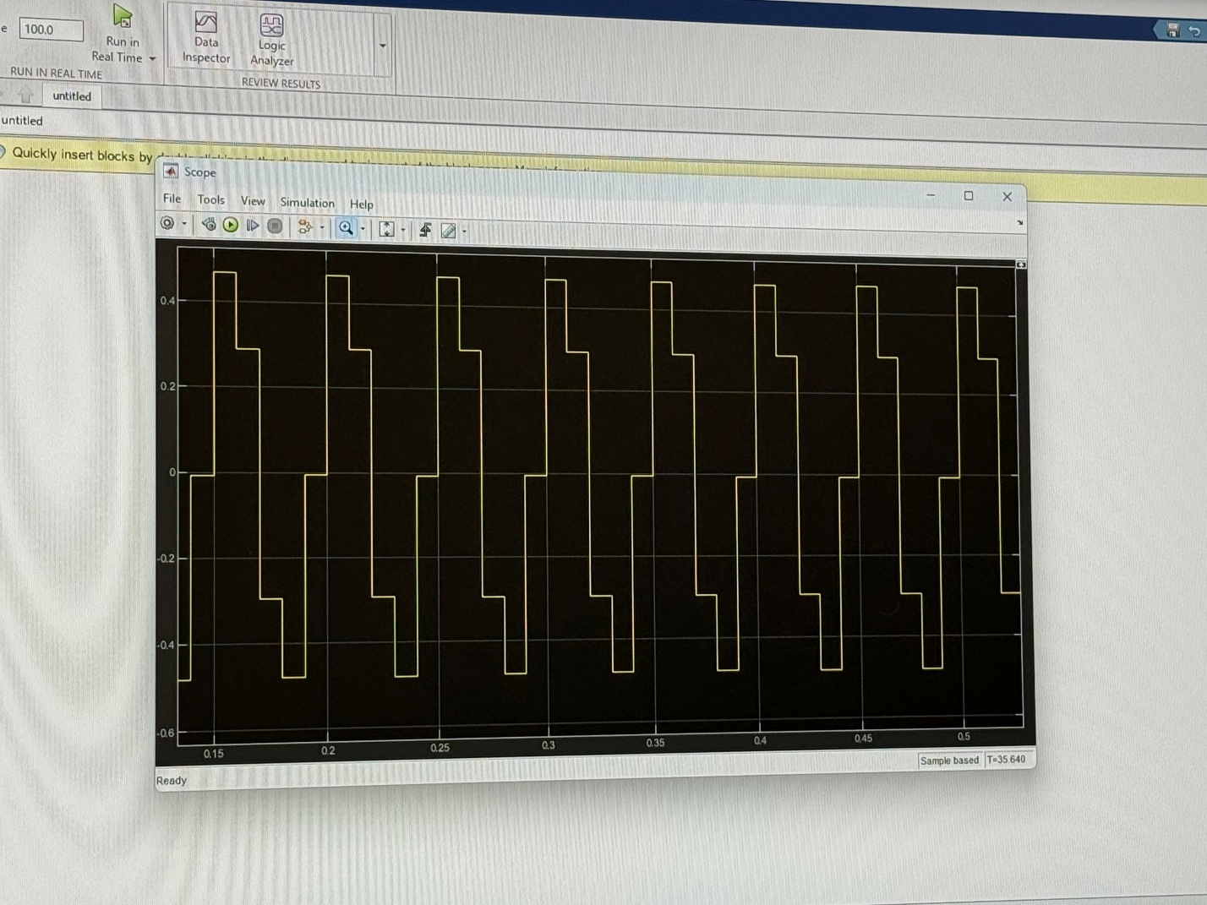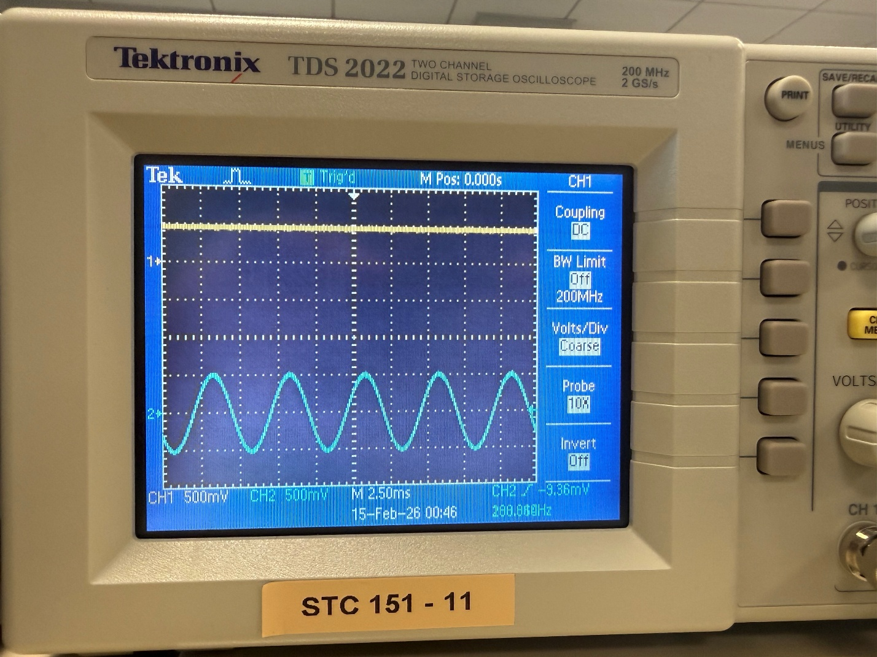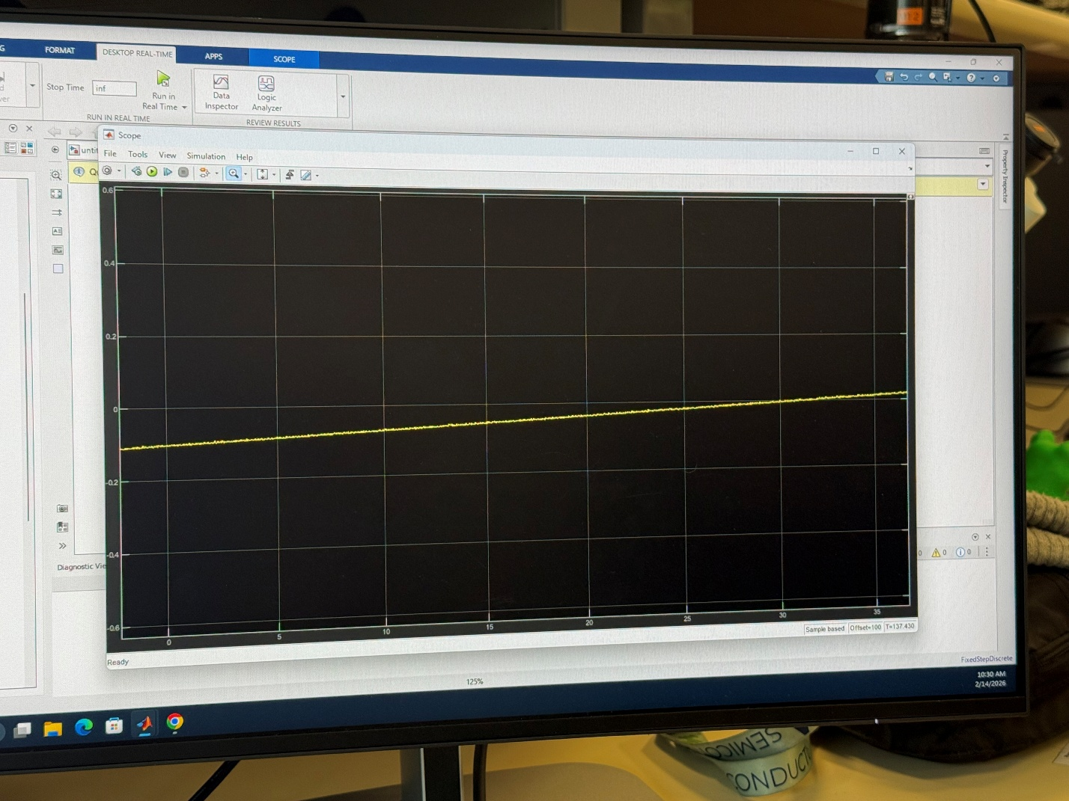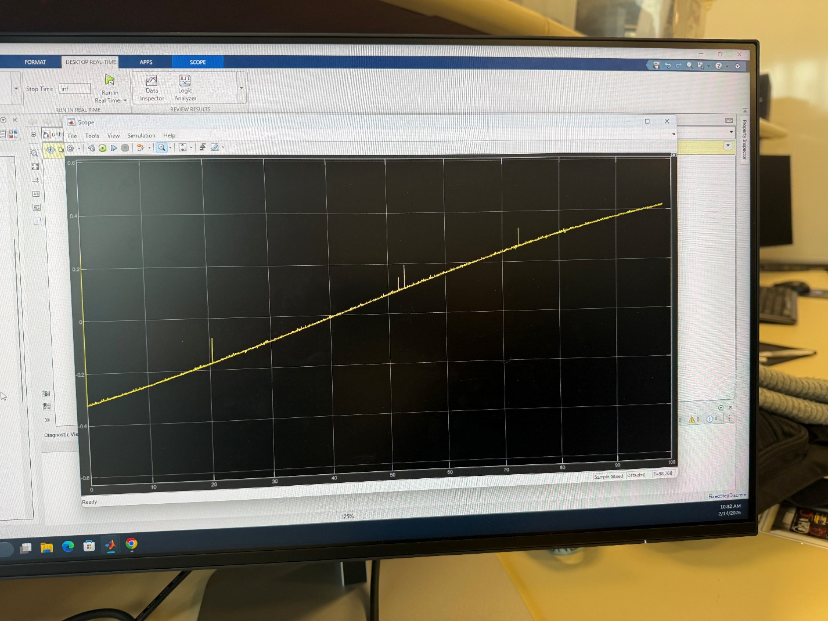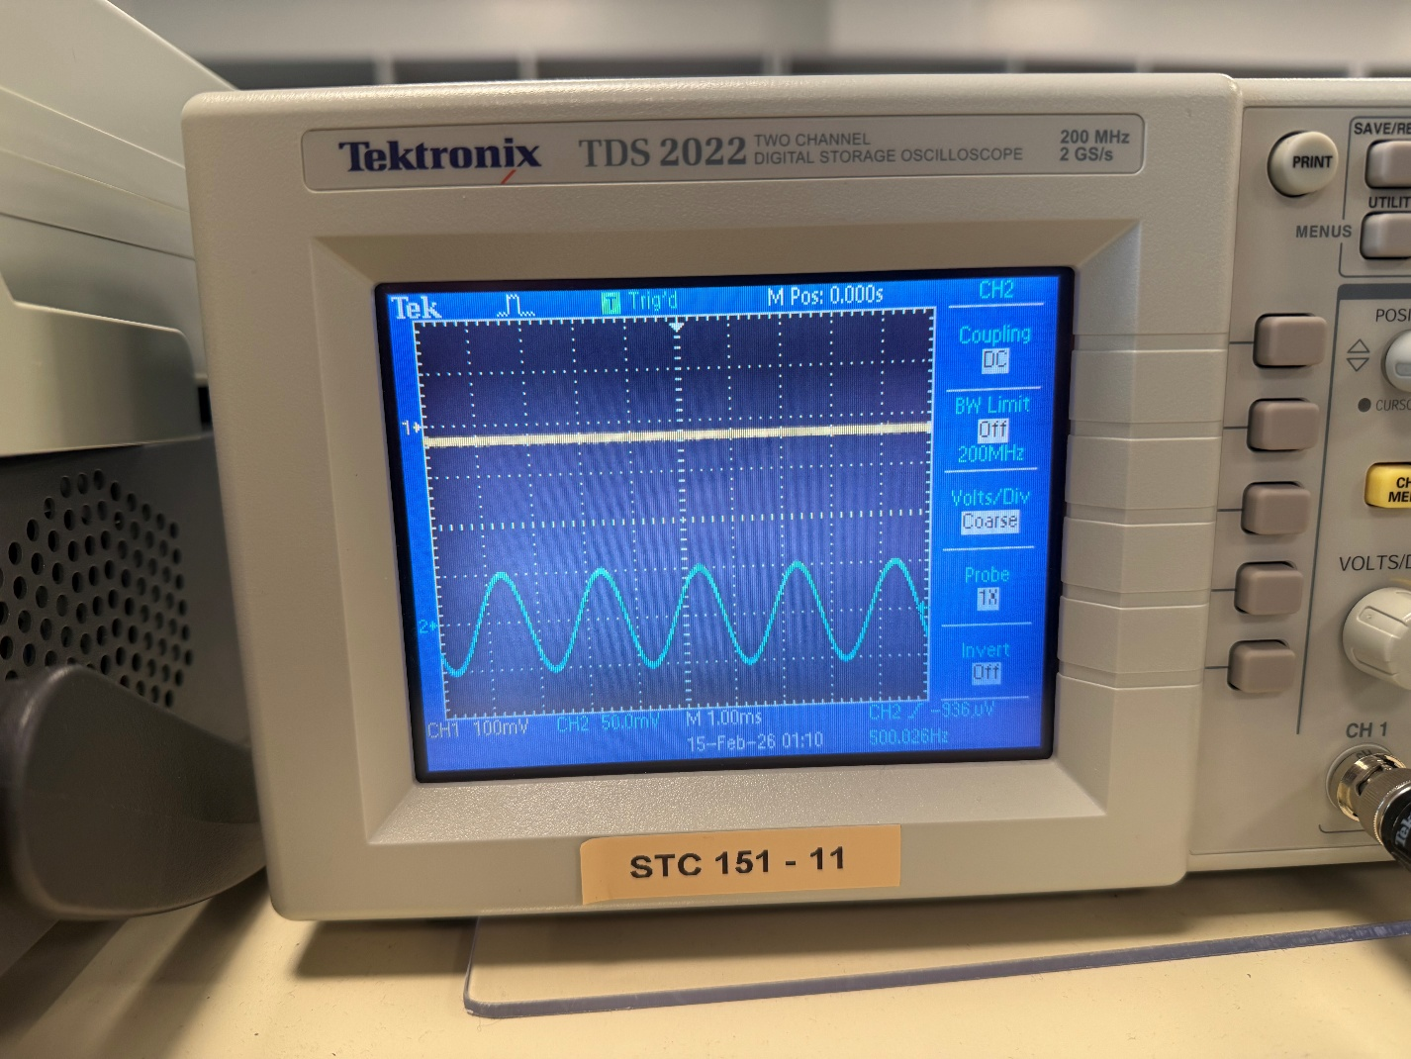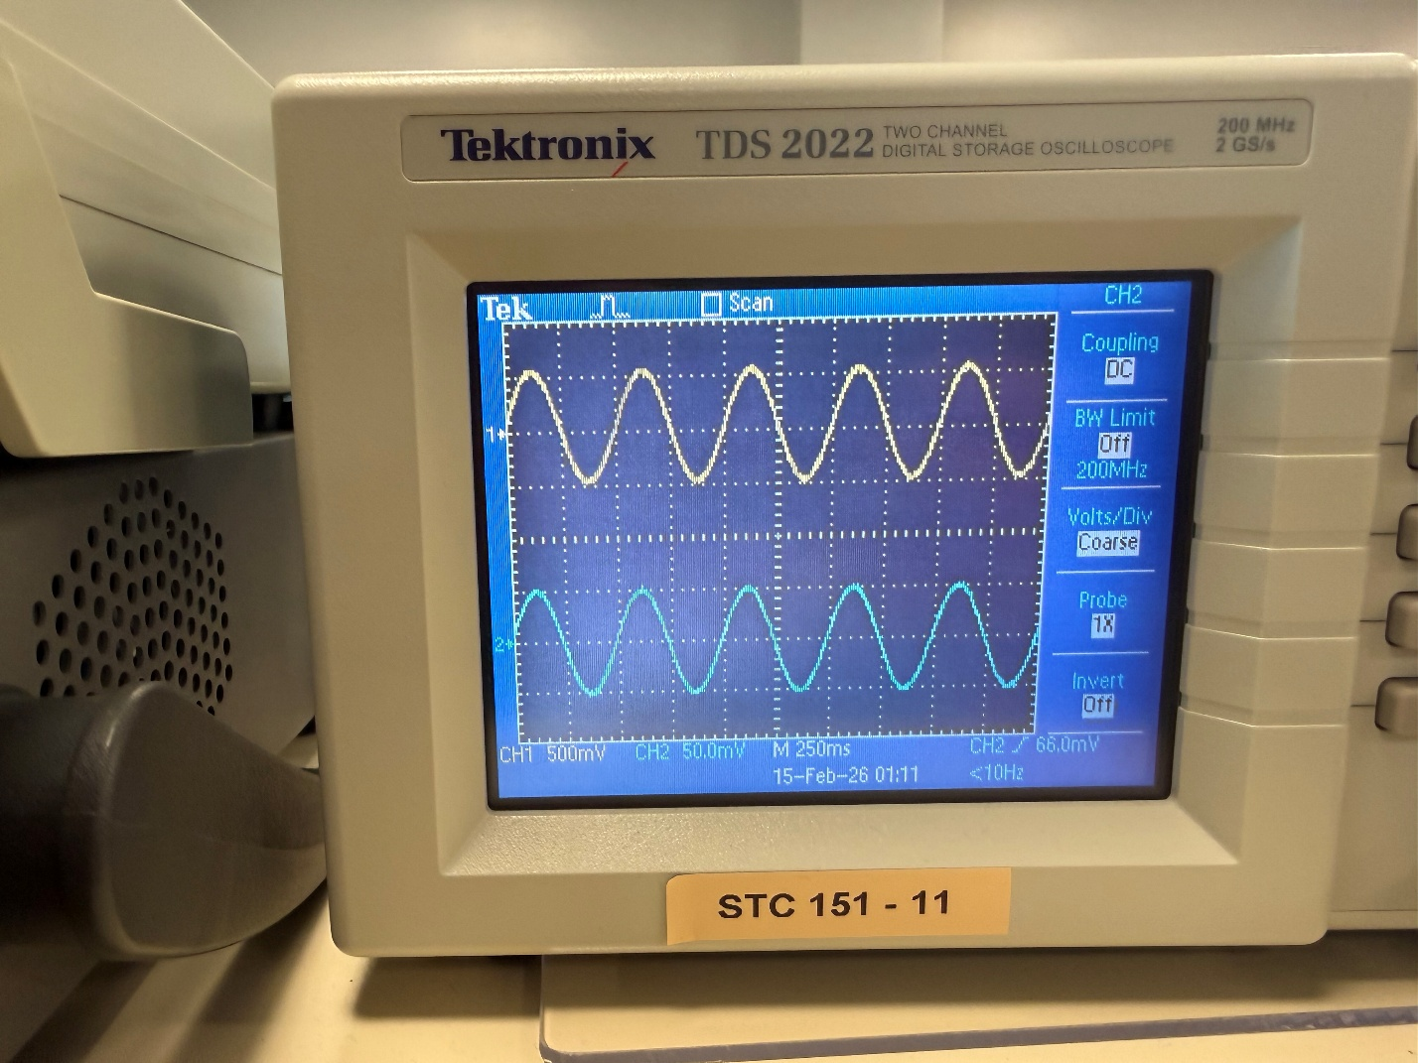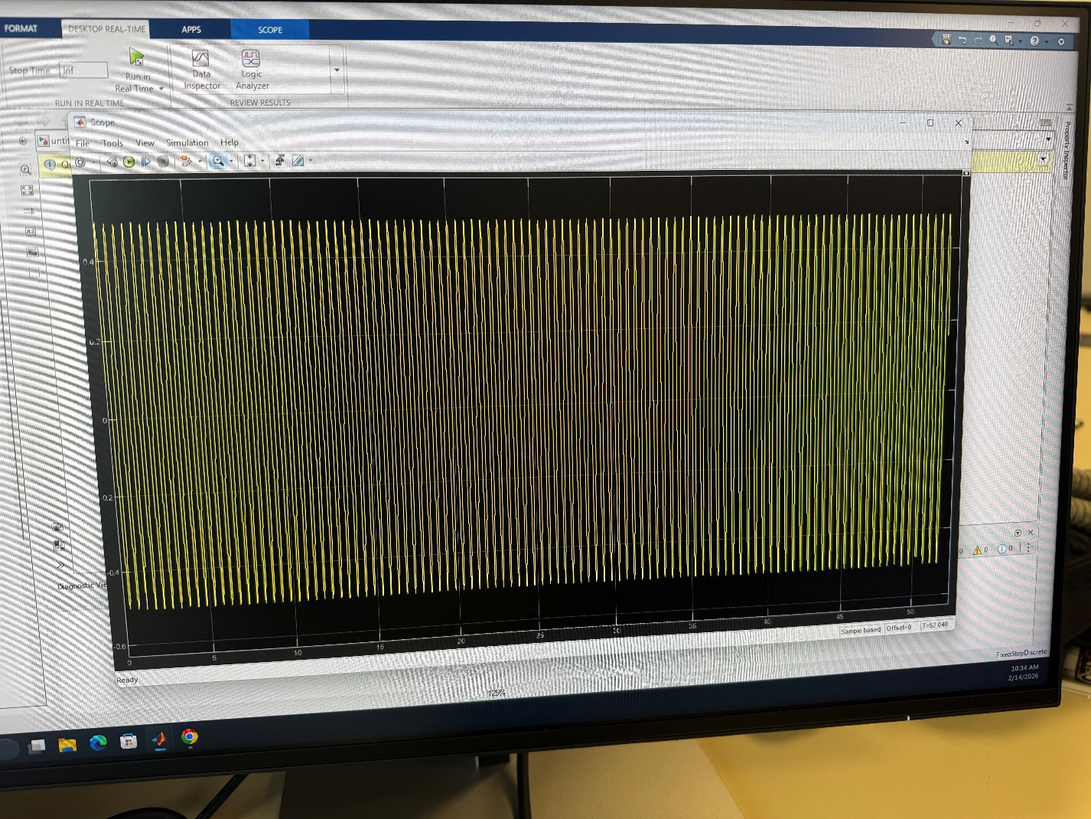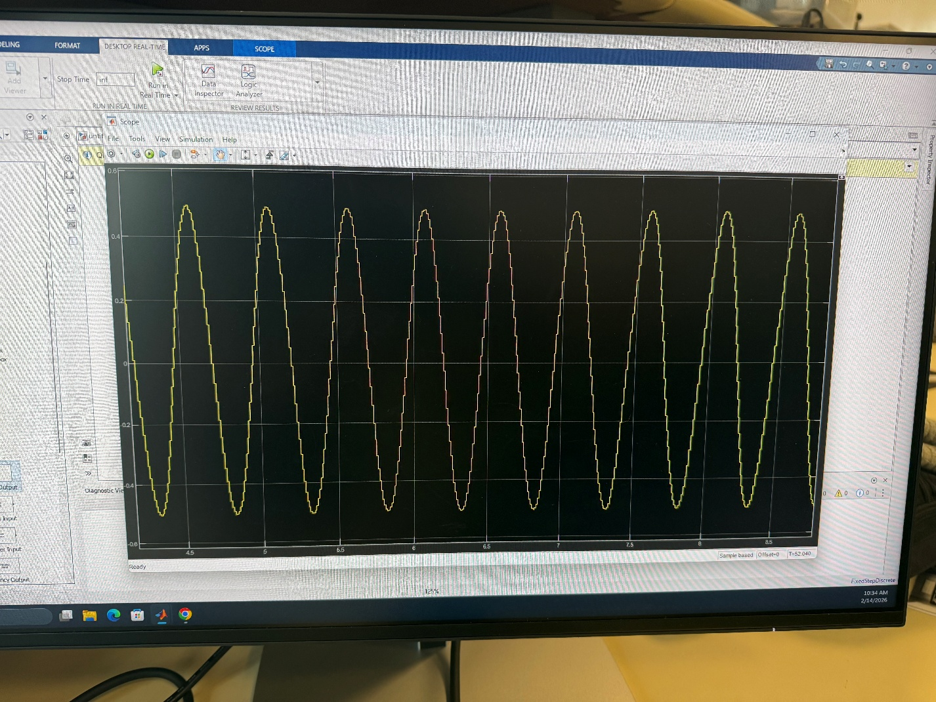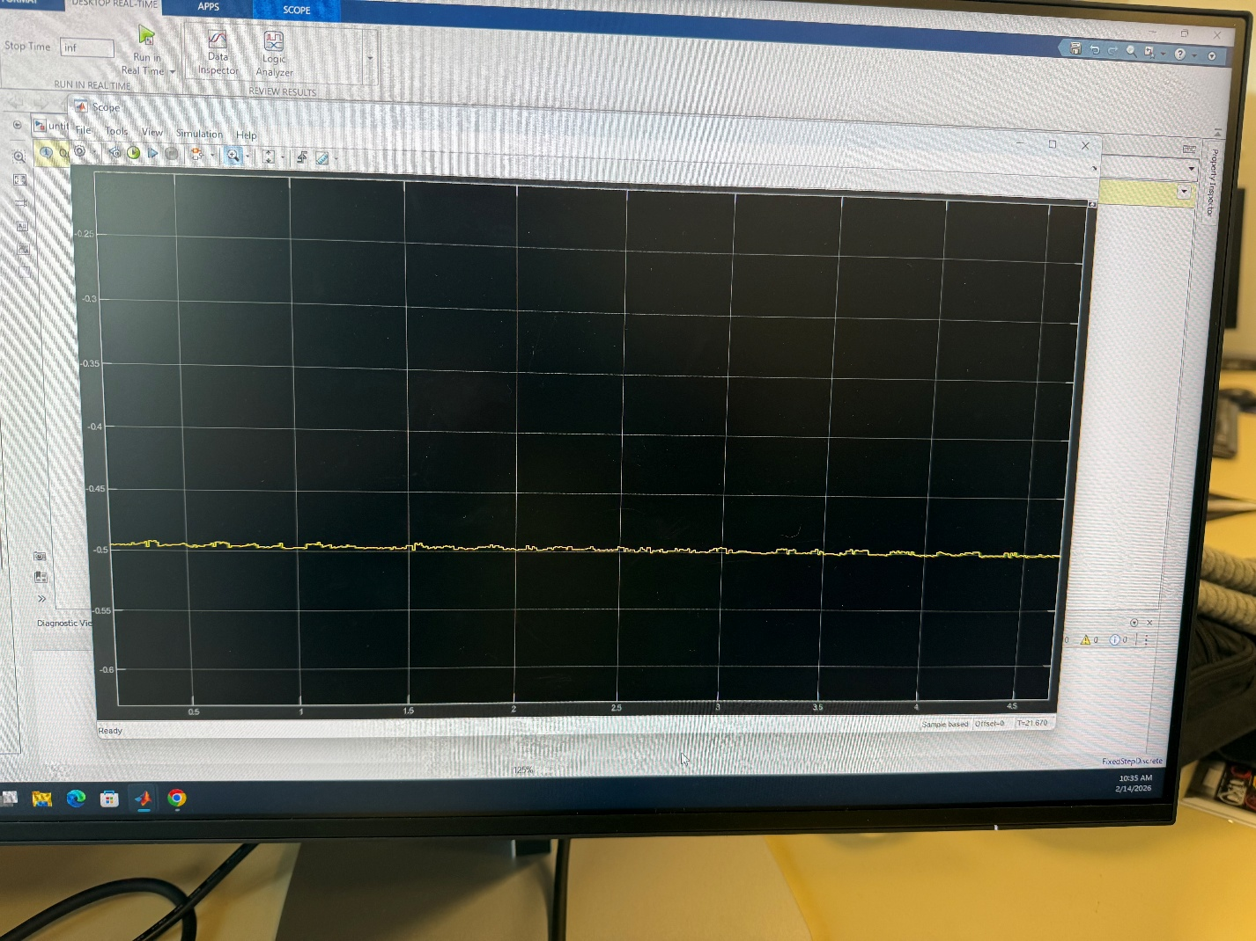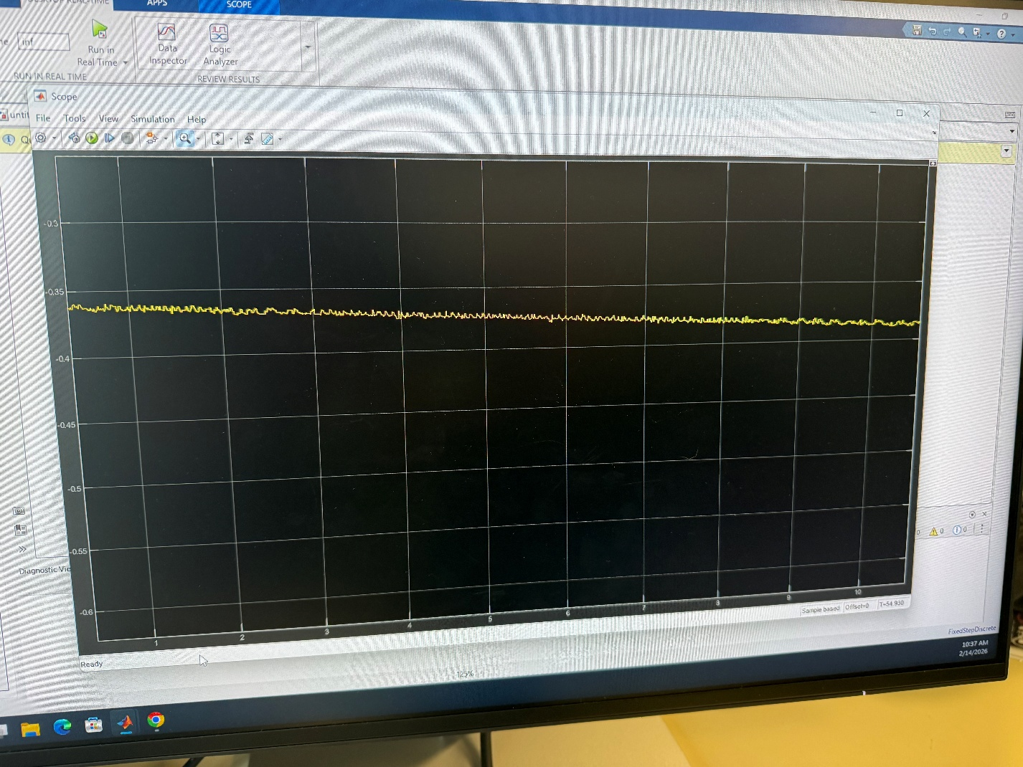

# Conclusion

Write a conclusion.

Also submit • any MATLAB scripts and Simulink models you created while doing the lab

Conclusion - At least 4-5 meaningful sentences

Ideas of things you could discuss:  
- What you learned  
- What you struggled with and how you overcame it  
- Application of lab in future  
- Comment on what lab results mean (Analyze)  
- Future improvement of the lab